How-to configure Sparnatural

date: 2024-07-14-20

Sparnatural version: 9.0.0

[**Introduction 3**](#_134nsf11gxxe)

[**Conventions 3**](#_nxgqxdasaxlw)

[**Prerequisites 3**](#_n7f3lacezwjk)

[**Documentation files 3**](#_x4994h646umy)

[**Structure of the example ontology 4**](#_xxed2eq4yghf)

[**Configuration spreadsheet 5**](#_b731jewoodc4)

[Protégé vs. spreadsheet 5](#_c0jag67mpq8x)

[The Excel-2-RDF converter 5](#_wh142o6njtnf)

[If you use a Google spreadsheet 6](#_d496lyhfqij0)

[If you use a local spreadsheet 7](#_39wu5oucw3nn)

[**Filling-in the configuration spreadsheet 8**](#_optcq49s2omt)

[Adjusting the configuration URI and the prefixes 8](#_j49u8amf3e70)

[Configuration IRI 8](#_fvsuv6tgivpc)

[Metadata cleanup 9](#_dquyrxsa0x3o)

[Prefixes 9](#_uvdu0hhnq9qv)

[Declaring Entities 9](#_ur3sjqgn2ede)

[Declaring properties 11](#_1fehovkt5pla)

[Selecting property types (widgets) 14](#_qjgkb0vzqbsg)

[Populating lists and autocomplete fields (datasources) 15](#_szmre0z3wjq3)

[Using predefined datasources 15](#_urdhjnsew8i5)

[Using predefined queries with your own properties 18](#_mb6dpyllc0ey)

[Declaring literal Entities 19](#_tdzsuipio9md)

[How-to set some properties optional or negative 22](#_usr27vpsgbbv)

[How-to map Entities and properties to the underlying data model 25](#_2ctq3xbe7i41)

[General mechanism 25](#_gvnxzgapz1c)

[Querying a sequence of properties (using a shortcut) 25](#_5x2n3bxe4dx3)

[Querying inverse properties 27](#_hws6l1qrbuz2)

[Querying multiple properties in a single criteria 29](#_6gcb92sv81uk)

[Querying a property recursively 30](#_h1b66wz2oucl)

[Combining property paths 31](#_rf2ygdaslbol)

[When the same property is used on multiple Entities 31](#_hv3ypc24jxal)

[Querying a subset of an Entity 32](#_joxpwmasfi6w)

[Querying more than one entity 33](#_gn86r0w6dv8c)

[**Create a Multilingual configuration 33**](#_za9n3lxkf9gn)

[Displaying labels in the result table 35](#_vywue8uy8rse)

[Default label properties 35](#_kmiilevbt32l)

[Multilingual default label properties 36](#_9oti0ryxotc7)

[**Advanced configuration 38**](#_eu15p0ikcysq)

[Advanced configuration : creating custom datasources 38](#_w2emliijpepk)

[Advanced configuration : debugging custom datasources 40](#_ep0rzgdo1ll7)

[Advanced configuration : setup tree widget datasource 42](#_ypsx3iv0v9d)

# Introduction

Welcome to this guide on how to configure Sparnatural !

The [Sparnatural SHACL configuration reference documentation](http://docs.sparnatural.eu/SHACL-based-configuration.html) lists the available annotations and axioms available to configure Sparnatural. In this documentation you will learn how to use these annotations concretely and define the Entities, properties, widgets and datasources in order to make your Sparnatural explorer as appealing as possible for your users.

# Conventions

URIs are indicated like this.

Headers in the spreadsheet are indicated like this.

**Important** : this is an important note, pay attention !

**Advanced note**: this is explaining something advanced. Don’t worry if you don’t understand all the details at first.

**Tip**: this is a useful and practical tip.

# Prerequisites

1. Make sure you have followed the introductory “Hello Sparnatural” guide to setup your environment to point Sparnatural to your triplestore and adjust the browser security settings.
2. You must have a local spreadsheet editor, like Microsoft Excel.
3. Although not absolutely required, it is good if you have a basic understanding of [SHACL specifications[[1]](#footnote-2)](https://www.w3.org/TR/shacl/). To go further with SHACL, you will also discover end of this manual how you can generate a documentation based on your Sparnatural SHACL configuration
4. For configuring your own datasource queries, you need to be proficient with SPARQL. This is described in annex.

# Documentation files

This guide comes with a set of files that you should have ready. Click on the links to download them:

1. [**car.ttl**](http://docs.sparnatural.eu/how-to-configure/car.ttl) : a sample OWL ontology describing car diagnostics.
2. [**car\_instances.ttl**](http://docs.sparnatural.eu/how-to-configure/car_instances.ttl) : a few manually crafted instances of the sample ontology. Although not strictly required, you should load these instances into your triplestore if you want to follow along and test the example configuration against the dataset.
3. [**sparnatural-car-configuration.xlsx**](http://docs.sparnatural.eu/how-to-configure/sparnatural-car-configuration.xlsx) : the example Sparnatural Excel config file
4. [**sparnatural-car-configuration.ttl**](http://docs.sparnatural.eu/how-to-configure/sparnatural-car-configuration.ttl) : the result of converting the Excel config file with the Excel-2-RDF converter. This is the actual Sparnatural configuration file to pass in the “src” attribute of the sparnatural HTML element, if you want to test it to see the final result (but this is not required to follow this documentation).

# Structure of the example ontology

For the purpose of this documentation we will use an example ontology, defined in car.ttl, and described in the following diagram:

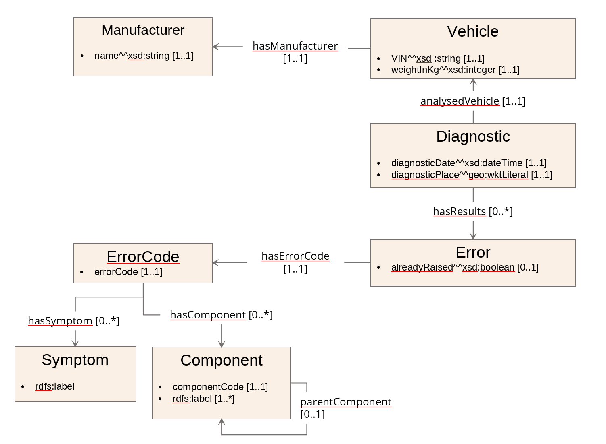

This is a simplistic representation of “On-board diagnostic” systems of cars : Vehicles, identified by their Vehicle Identification Number (VIN) have a manufacturer; Diagnostics are made on given vehicles at a certain date and a certain place, and can yield errors. An error has a code, and a flag indicating if the error was already detected on the same vehicle. Error codes are associated with symptoms (“Engine Misfire” or "Transmission Slipping") and components (“Engine”, “Transmission”, “Brakes”). Components are hierarchically organized.

The ontology uses the prefix “odb” associated with the URI [http://example.com/ontology/odb#](http://example.com/ontology/odb).

**Disclaimer :** this “car” ontology sample is a fictitious one, which has only been created for the purpose of testing maximum Sparnatural different functionalities. This ontology might not be fully exact nor complete in a real car diagnostic industrial context ! [[2]](#footnote-3)

# Configuration spreadsheet

## USING A spreadsheet TO CONFIGURE SPARNATURAL

Sparnatural can be configured by a SHACL ontology, and the “Hello Sparnatural” guide explains how to use a simple Excel spreadsheet to start creating a SHACL config ontology for Sparnatural.

The config can even be edited live in case of online spreadsheets !

The conversion of the spreadsheet into SHACL requires the Excel-2-RDF converter :



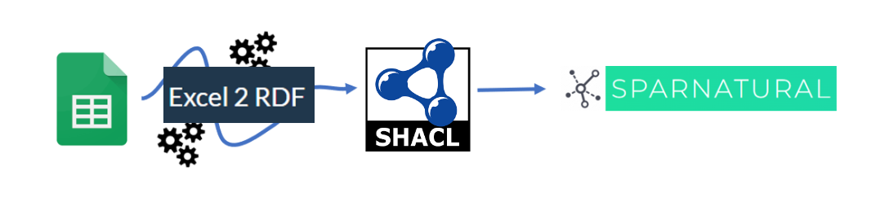

## The Excel-2-RDF converter

The code of the converter is open-sourced in the [xls2rdf Github repository](https://github.com/sparna-git/xls2rdf). The Excel-2-RDF converter is available in different packagings:

1. an [online REST service](https://xls2rdf.sparna.fr/rest/)
2. an [online form](https://skos-play.sparna.fr/play/convert) where you can upload your file
3. a [command-line converter](https://github.com/sparna-git/xls2rdf/releases) with [its documentation](https://github.com/sparna-git/xls2rdf/wiki)
4. a [Java library file](https://github.com/sparna-git/xls2rdf/releases) to be integrated into your application

All these “packagings” behave the same way for the conversion of the spreadsheet in RDF. For the purpose of following this documentation, we suggest either using an online Google spreadsheet and rely on the online conversion service, or simply use a local file and upload it through the online form, and save the resulting SHACL file.

The detailed behavior of the Excel-to-RDF converter as to how the Excel file is interpreted is out of scope of this guide, and is [documented in the online converter service](https://xls2rdf.sparna.fr/rest/doc.html).

## If you use a Google spreadsheet

Using a Google spreadsheet has the following advantages:

1. The configuration is “live” : while in the test phase, you can edit your spreadsheet, refresh your Sparnatural HTML page, and it will be updated automatically.
2. Multiple persons can collaborate on the same config spreadsheet.

To initialize your configuration spreadsheet:

1. [Make a copy](https://docs.google.com/spreadsheets/d/1lduSARo-zyL8qxObwPVD4Z2m8iKQpye-/edit?gid=792284404" \l "gid=792284404) of the configuration template
2. Your spreadsheet needs to be publicly visible. You need to share it with the *"Anyone with the link = Viewer"* option. To do this, select the option **Share**.

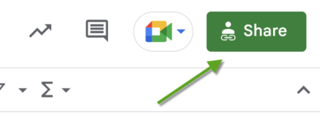

In the next window, click the **"General access"** button. Select the *"Anyone with the link"* option and press the "Done" button.

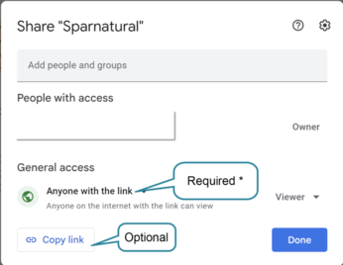

After you close the window, copy the URL of the spreadsheet in your browser's address bar.

1. Copy this URL in the cell B2 of the configuration file. Make sure the URL does not end with “/edit#gid=xxxxxxx”, remove this part of the URL manually. The URL should look like [*https://docs.google.com/spreadsheets/d/xxxxxxxxxx*](https://docs.google.com/spreadsheets/d/xxxxxxxxxx.)”
2. Save the content of cell B3 (in red) : this is the configuration URL that you can pass to the “src” attribute of the <spar-natural> HTML element. You see it starts with [https://xls2rdf.sparna.fr](https://xls2rdf.sparna.fr/) : this is the online Excel-2-RDF conversion service that takes the Google spreadsheet URL as a parameter. Each time your sparnatural page will load, it will call this URL of the converter, which will in turn trigger the conversion of the Google spreadsheet. The page is connected “live” to the spreadsheet.

**Important** : once your configuration is ready, do NOT leave Sparnatural pointing to the live spreadsheet, otherwise your page will depend on the availability of the online converter. Instead, save the result of the conversion to a local file “sparnatural-config.ttl”, and adjust the “src” attribute of the <spar-natural> HTML element to point to the local file.

## If you use a local spreadsheet

Relying on Google services might not be applicable in every context. It is also possible to design the configuration in a local spreadsheet, and convert it to a SHACLfile. The configuration is not live in that case, and you will have to reconvert the file every time you make a change in it.

To start a fresh configuration template:

1. Download the [configuration spreadsheet template](https://docs.google.com/spreadsheets/d/1lduSARo-zyL8qxObwPVD4Z2m8iKQpye-/edit?gid=792284404" \l "gid=792284404).
2. Edit the content as necessary
3. Go to the online converter at <https://skos-play.sparna.fr/play/convert>
4. Upload the file in the field “in a local file on my computer”: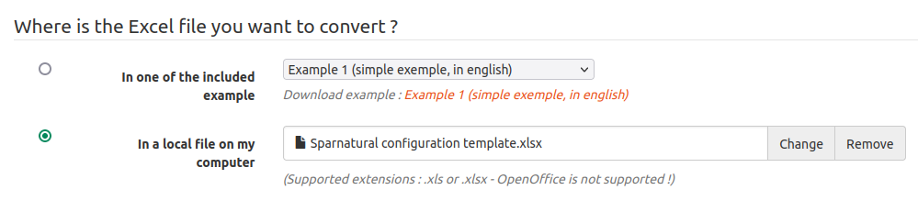
5. Check the box “Ignore SKOS post-processings on the data”: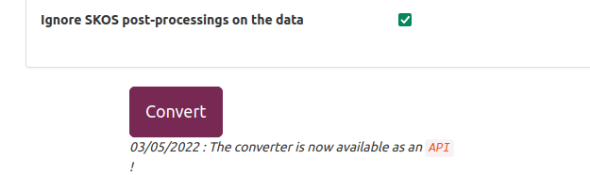
6. Click on Convert.
7. Save the resulting file in the same folder as your Sparnatural page.
8. Adjust the “src” attribute of the <spar-natural> HTML element to point to this local file.

Reconvert the file the same way every time you make a change in it.

# Filling-in the configuration spreadsheet

In this documentation we will work with a local spreadsheet. Download the [spreadsheet configuration template](https://docs.google.com/spreadsheets/d/1lduSARo-zyL8qxObwPVD4Z2m8iKQpye-/edit?gid=792284404" \l "gid=792284404) and save it in a local file. You will be working on this local file.

|  |
| --- |
| **Important** : throughout this documentation, we are referring to the columns of the spreadsheet by their header name. The header is the green line in bold:    Each column header corresponds to one configuration property as detailed in the [http://docs.sparnatural.eu/SHACL-based-configuration.html](http://docs.sparnatural.eu/OWL-based-configuration.html). The header line does not need to be at a fixed line; it is automagically detected, so don’t worry if you add or delete lines before this one. |

## Adjusting the configuration URI and the prefixes

You first need to adjust the URI of your configuration, as well as enter the prefixes used in your knowledge graph.

### Configuration IRI

Make sure you are on the “Entities” tab of the configuration template, and edit the content of cell B1. This cell needs to contain the URI of your configuration. It is not very important, unless you plan to share your configuration later. It is typically set to something like “<https://data.mydomain.com/sparnatural-config>” or to a URL where Sparnatural will be deployed, like “<https://mydomain.com/sparnatural-page/sparnatural-config>”.

### Metadata cleanup

Cells B2 and B3 are only useful when working with online Google spreadsheets, so that the configuration can be automated. We don’t need that in a local file, so simply delete the content of cells B2 and B3. Keep them if you work with a Google spreadsheet.

### Prefixes

You need to add additional prefixes from your configuration. Some prefixes are already declared in the “Prefixes” tab. Leave them as they are there, and add additional prefixes if necessary. The column A always needs to contain the keyword PREFIX, column B is the prefix name, and column C is the complete URI associated with the prefix.

Don’t hesitate to add new lines if you need to add many prefixes.

|  |
| --- |
| ***Example***  Following the above, in our example configuration we set the Configuration IRI to <http://example.com/sparnatural-page/sparnatural-config>, delete the content of cells B2 and B3 in the “Entities” tab, and in the “Prefixes” tab, add our prefix “odb” on line 9, corresponding to the URI [http://example.com/ontology/odb#](http://example.com/ontology/odb) |

## Declaring Entities

Now you can start filling in the table with the Entities of your configuration. Don’t hesitate to read the guidelines in the green line above the body of the table.

* always use the "this" prefix in the "URI" column and enter the class URI in the sh:targetClass column ;
* in column sh:order^^xsd:integer set the display order of each entry to sort the items in Sparnatural’s interface. The value must be an integer ;
* the volipi:iconName column is where you can copy-paste the code of a [Font Awesome free icon](https://fontawesome.com/search?o=r&m=free) you will choose on the website (e.g. “fa-solid fa-car”) ;
* then in the rdf:type column set sh:NodeShape as the value of all your Entities items ;
* then add the label of your Entities, in the rdfs:label@xx column (these will appear as the coloured named “blocks” in the query builder).

**Advanced note**: You can change the language of the label by editing the header row. By default the template enables labels in English (rdfs:label@en), and French (rdfs:label@fr). You can adjust the language code after the “@” sign. All the labels in a given column will be tagged with this language. Make sure the language you use matches the “lang” parameter of Sparnatural in your webpage. More on this in the section about multilingual configuration.

* if you need some, you can also add tooltips in the sh:description@en column. This is not mandatory. Depending on the use-case, the tooltip may provide more contextual information to the user than only the definition from the ontology (e.g. *“Select this entry if you want to search on xxx or yyyy”*).
  + Similar to labels, you can adjust the language code of the tooltips by editing the language code after the “@” symbol in the header line.

**Tip**: HTML markup is supported in tooltips.

**Tip**: By using the labels combined with the order, you can group your Entities in a meaningful way, for example by setting a label that contains a hierarchy, such as “Actor > Person” and “Actor > Organization”, and setting those 2 classes next to each other with their order.

|  |
| --- |
| ***Example***  Here in the example we have chosen to list all the existing Entities of the model (you could choose to have only some classes of your model, and not all). We took the same URIs as the ones in the data model and added order, icons, labels and tooltips :    We decided that “Vehicle” was an important entry point and set its order to 1. Following this, we can see it appears first in the query builder :    Note how the tooltip displays the definition from the configuration. |

## Declaring properties

Same process then to set the relations between the classes : jump to the “Properties” tab, 2nd of the spreadsheet.

**Tip**: We suggest you organize this table by sections, each section corresponding to the specification of the properties attached to one given class in your configuration. Make a colored line for each section, with the name of the class as the title. Generally you are free to arrange the spreadsheet as you want and use any formatting/color option you want. Lines that do no contain a URI in column A will be ignored.

In this tab you will enter:

* URI column : URI of your property, following a particular syntax :

- typically using the prefix from your configuration (the « this » one) ;

- then just concatenate the Entity identifier from column C (the « ^sh:property » one) ;

- add an underscore for better readability ;

- and finally the property identifier from your ontology (the « sh:path » one)

Which gives us for example : "this:Vehicle\_VIN" ;

* the sh:path column is for the URI of the property from your ontology ;
* the ^sh:property is the Entity URI to which the property is assigned (as the “subject” of the assertion in an RDF graph) ;
* in the “sh:name@en” column set the label of the property to be shown in the interface ;
  + adjust the language code of the labels by editing the language code after the “@” symbol in the header line.
* if needed you can add a tooltip in the sh:description@en column ;
  + adjust the language code of the tooltips by editing the language code after the “@” symbol in the header line.
* the sh:class is the Sparnatural Entity to which the property points to (the “object” of an RDF predicate);
* dash:searchWidget

**Advanced note**: it is possible that a single property has more than one Entity as its domain. You can specify more than one Entity identifier in the ^sh:property column, by separating them with a comma.

|  |
| --- |
| ***Example***  Note how the table is organized with one section per Entity; note also how each property refers to the Entity to which it is attached in the ^sh:property column (in each “section” the ^sh:property is always the same), and the Entity to which it refers to in the sh:class column.    As a result we can see - when index.html is refreshed - the object properties *in italic* appear in the interface, between the Entities items :    The tooltip of the property is displayed if it was added before in the configuration file.  We see a dropdown list appears when the range of the query (i.e. the “object” Entity of the assertion) is chosen. As explained before, the way the selected values are to be displayed depends on the type (dash:searchWidget) of the property, also referred to as the “widget” of the property. |

## Selecting property types (widgets)

For now Sparnatural offers the following ways of selecting a value for a criteria :

|  |  |
| --- | --- |
| Widget type (dash:searchWidget) | Description |
| **core:ListProperty** | dropdown list widget |
| **core:AutocompleteProperty** | autocomplete search field |
| **core:TreeProperty** | tree browsing widget, useful with some tree-shaped values, typically SKOS hierarchies, part-of hierarchies, etc; |
| **core:MapProperty** | map selection widget (GeoSPARQL queries) |
| **core:SearchProperty, core:StringEqualsProperty, core:GraphDBSearchProperty** | string search widget, searched as regex or as exact string |
| **core:TimeProperty-Date, core:TimeProperty-Year** | date range widget (date or year precision) |
| **core:BooleanProperty** | boolean widget (true/false, yes/no values…) |
| **core:NonSelectableProperty** | no value selection (useful for 'intermediate' Entities whose values don’t need to be displayed) |
| **core:NumberProperty** | Numeric range widget |

All of them are already fully documented in the [reference documentation for Sparnatural widgets](https://docs.sparnatural.eu/widgets.html) .

The choice of the widget is driven by how we want the user to select a value, and how many different values are available (e.g. lists are good only when the values are relatively small, typically less than 500 distinct values).

|  |
| --- |
| ***Example***  Note how the properties in our configuration uses different kinds of widgets:    On Manufacturer, we have set the odb:name property as core:NonSelectableProperty, because we assume the user will never have to search or select a value for the name of a Manufacturer.  On Vehicle, the odb:VIN property is set as an autocomplete. Being a long technical identifier, having an autocomplete will help user selecting a correct value. The odb:manufacturer property uses a core:ListProperty because there is a limited list of possible car manufacturers, so using a list is convenient.  On Diagnosis, odb:diagnosticDate uses a date property as the values in the graph have an xsd:date datatype. |

## Indicating the default label property for each Entity

Expliquer que pour chaque entité, on peut “marquer” une (et une seule !) de ses propriétés comme étant la propriété de libellé par défaut.

Cette information est utile pour 2 choses :

1. L’affichage du libellé dans les résultats d’une requête
2. L’affichage du libellé dans les listes déroulantes de choix dans Sparnatural, et dans les champs de recherche avec autocompletion

Ajouter un encadré avec l’exemple qui expliquer les libellés par défaut des entités du modèles.

## Populating lists and autocomplete fields (datasources)

### Default datasource behavior

By default, properties using a ListProperty widget will leverage the dash:propertyRole flag to provide the following default behavior : the list will contain the value of the property flagged as “dash:LabelRole” of the Entity that is indicated in the “sh:class” column. The list is sorted alphabetically.

For example, for the property “odb:hasErrorCode” on Error, the list will be populated with the “odb:errorCode” property, since it is marked with “dash:LabelRole” in the sh:propertyRole column.

(ajouter un screenshot)

By default, properties using an AutocompleteWidget will leverage the dash:propertyRole flag to provide the following default behavior : the search field will search on the content of the property flagged as “dash:LabelRole” of the Entity that is indicated in the “sh:class” column. The search is done at any position in the character string.

For example, the property “odb:analysedVehicale” on Diagnoses will search on the “odb:VIN” property of Vehicles, since it is marked with “dash:LabelRole” in the sh:propertyRole column.

There is no default behaviors for TreeProperty.

In most of the cases, the default behavior is sufficient to deal with the most common use-cases. In more advanced situations, other means of configuring the datasources of lists and autocomplete fields are possible, and documented below.

### Using predefined datasources

ListProperty and AutocompleteProperty can use a datasource to be populated differently than their default behavior. For that purpose use the datasources:datasource column of the Properties tab. The datasource of a dropdown list populates the list, the datasource of an autocomplete property feeds the autocomplete proposals. TreeProperty also requires two datasources; the configuration of tree datasources is covered in annex.

In its most simple form, a datasource is a SPARQL query that will return some results.

Sparnatural comes with off-the-shelves datasources, in tab “sparnatural-config-core” of the spreadsheet. Here you can find a list of preconfigured datasources corresponding to different widget types for lists, autocomplete (search) and tree.

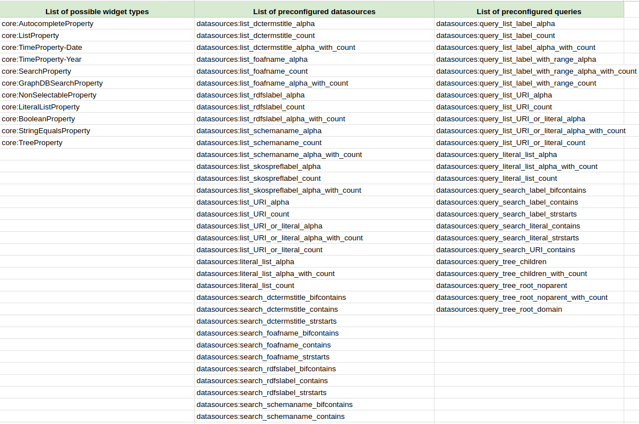

The predefined datasources are documented in the [datasource documentation of Sparnatural](http://docs.sparnatural.eu/OWL-based-configuration-datasources.html), but we give some simple indications to select the adequate one for your use-case:

* datasources beginning by “list” are for ListProperty, while datasources beginning by “search” are for AutocompleteProperty.
* The identifier of the property indicates which property Sparnatural uses to display the entry or search on it : rdfs:label, foaf:name, dcterms:title, schema:name, skos:prefLabel
* List datasources come in 3 variants : “alpha” is pure alphabetical, count is sorted by descending number of occurrences, “alpha\_with\_count” is alphabetical but displays the number of occurrences in parenthesis.
* Search datasources come in 3 variants : “strstarts” looks for the string at the beginning of the property, “contains” looks for the string anywhere in the property, “bifcontains” is specific to Virtuoso and will look for the string anywhere in the property but as a complete word/token.

A typical frequent choice to populate a list is the datasource “datasource:list\_rdfslabel\_alpha” which will populate a list with the rdfs:label of the values, sorted alphabetically.

**Advanced note**: if you look at the SPARQL queries (e.g. by navigating to [the URI of one “query\_list\_xxxx”](http://data.sparna.fr/ontologies/sparnatural-config-datasources" \l "query_list_label_alpha)), you will notice that the default provided queries do not use the range class as a criteria in the query, mostly for performance reasons. They assume that a given property always refers to a single type of Entity. If you have a property that can refer to multiple classes as range, then you need to use one of the provided query that includes “with\_range” in its name (e.g. datasources:query\_list\_label\_with\_range\_alpha), and inject the property name in it (see following section)

**Advanced note**: if you don’t specify any datasource, and there is no dash:LabelRole flag on the target Entity for the property, Sparnatural will default to [datasources:list\_URI\_or\_literal\_alpha](http://data.sparna.fr/ontologies/sparnatural-config-datasources" \l "list_URI_or_literal_alpha) for lists and to [datasources:search\_URI\_contains](http://data.sparna.fr/ontologies/sparnatural-config-datasources" \l "search_URI_contains) or [datasources:search\_literal\_contains](http://data.sparna.fr/ontologies/sparnatural-config-datasources" \l "search_literal_contains) (depending if the range class is marked as a literal or not, see below). You will most probably never use these defaults and always specify a datasource.

|  |
| --- |
| ***Example***  Both lines in grey below correspond to list properties (“core:ListProperty”) “hasSymptom” and “hasComponent” respectively with “Symptom” and “Component” as range values, where we wanted the sh:name@en in an alphabetical way to be displayed :  montrer 1 comportement default  + 1 error code has symptom où on ajoute 1 datasource :  exemple sur ErrorCode\_hasSymptom : on spécifie la datasource "datasources:list\_rdfslabel\_count" pour avoir une liste avec le comptage    That gives us the following result when shown in Sparnatural’s interface :    We can see that we obtain an alphabetically-sorted list of labels here (instead of URIs). |

### Using predefined queries with your own properties

When your data model uses a property to label Entities other than one of the 5 for which preconfigured datasources exist, you can create your custom one, based on one of the predefined query (alpha, count or alpha\_with\_count), in which your property will be “injected”.

To do so, go to “Datasources” tab of your spreadsheet and write down the URI of the new datasource you want to create in column A, using the “this:” namespace, using a name as explicit as possible. Then:

* in rdf:type column, always set the value datasources:SparqlDatasource
* In the datasources:queryTemplate column, pick one of the query from the sparnatural-config-core tab you will copy-paste in the corresponding column. The queries identifiers start with “datasources:query\_list…” or “datasources:query\_search…”
* In the datasources:labelProperty column, enter the URI of the label property in your data, either as a complete URI (surrounded by “<” “>”) or as a prefixed one. Your custom datasource is created, and can refer to its URI from the “Properties” tab in the “datasources:datasource” column.

|  |
| --- |
| ***Example***  Two examples of custom datasources here in the screenshot : first one to populate a simple list property with the odb:name label (alphabetical order), second one to trigger a “strstarts” search on VIN number labels for an autocomplete field property :    And this is what both custom datasources look like in the Datasources tab:    This way we obtain the following results on Sparnatural index page :  a dropdown list with particular labels instead of URIs :    an autocomplete field that could be filled in with the VIN numbers instead of the labels : |

## 

## Declaring literal classes

You will have cases when a property is not an “object property” (i.e. a property followed by another resource as a value), but a “data property”. There you may have to deal with literal data as values, typically xsd:string, xsd:boolean, xsd:date or xsd:dateTime.

Sparnatural configuration allows you to create special classes dedicated to literal data in order to enable the display of these particular values the same as other classes.

For that purpose you need to create a range class corresponding to the literal values you want to display. The only two differences with other classes is that:

1. the rdfs:subClassOf column must have the value rdfs:Literal instead of the usual core:SparnaturalClass (and don’t forget to add other attributes to the class : label, icon, tooltip if needed etc.)
2. you will use the “this:” namespace as the URI of this class

**Tip**: Either you can declare a single class for all literal values, such as “this:Attribute”, so that all literal properties are “grouped” under a generic “Attribute” entry, or you can choose to decompose by datatype, such as “Text”, “Date”, “Boolean”, or you can even decompose by properties, with one literal class per literal property (e.g. “Coverage” class corresponding to “coverage” property), which imply some kind of duplication. The strategy to use depends on how you would like things to be presented to your users.

The consequence of declaring a class as rdfs:Literal is that the generated SPARQL query will never contain an rdf:type criteria for such objects, since they are literal values.

Remember that literal classes won’t appear in the initial classes menu as they will never be used as the domain of other properties (only as range).

|  |
| --- |
| ***Example***  Back to the Classes tab, a view of the this:Attribute class (blue line) that will be used as a range class each time a property is to display literal values : as the class doesn’t really exist in the data, it is provided a “this” URI, and has the value rdfs:Literal in the rdfs:subClassOf column :    This way the corresponding literal properties are all pointing to the this:Attribute class as a range cf. rdfs:range column :    Then searching in the query builder for the VIN number of a Vehicle, that is a literal attribute, you can see the query when clicking on blue “Toggle SPARQL query” button :    Note how the query does \*not\* include an rdf:type criteria on this:Attribute. |

## How-to set some properties optional or negative

According to the SPARQL syntax, Sparnatural offers also a way to configure optional or negative assertions, corresponding in SPARQL to [OPTIONAL](https://www.w3.org/TR/sparql11-query/" \l "optionals) or negative “[FILTER NOT EXISTS](https://www.w3.org/TR/sparql11-query/" \l "neg-pattern)” query patterns.

Both parameters can be activated/inactivated for each individual property in the Properties tab of the spreadsheet. If you set “true” as the value of the column core:enableOptional^^xsd:boolean or core:enableNegation^^xsd:boolean, a clickable green arrow will appear in the query builder interface before the chosen property, enabling the user to make the property criteria optional or negative.

|  |
| --- |
| ***Example***  Here we can see in both last columns we have chosen to enable the Optional parameter for only one row (the “already raised” property) and a few more ones to set the negative parameter : theoretically you can apply both parameters to them all, but here we preferred allowing the option for relevant ones only (the choice depending on the existing data).  So regarding the optional parameter, the “already raised property” is the only one being facultative, so you may want to display optionally the existing values of it without excluding the blank ones in your query.  The negatives ones which are set on “TRUE” (“VRAI”) are those for which a negative query was judged meaningful from a user perspective.    The following screenshot shows an optional query pattern on the “already raised” property which is optional (cardinality [0..1]). Let’s imagine we’d like to display all the results following this property no matter *if actually there are some* (or not). This enables to obtain a list of results even in case when the value isn’t there :    This one shows a negative pattern where we want to search for every component related to an error code that does not have “Engine Misfire” as a symptom : |

# How-to map classes and properties to the underlying data model

By default, you use the URI identifiers of the classes and properties of your data model as the URI of classes and properties in your Sparnatural configuration. But you can also provide your users with a slightly different view of the underlying graph structure. Typically you might want to show them a simplified view of the more elaborate structure in the graph. To do this you will use different URI identifiers for classes and properties in your Sparnatural configuration, that will be remapped at query time to the underlying graph structure.

## General mechanism

Declare the new URI identifiers using the “this:” namespace. This means that these identifiers belong only to your configuration, not to your knowledge graph ontology.

The mapping is done through the core:sparqlString column in the “Classes” and “Properties” tab. *The string that you specify in the core:sparqlString annotation will be inserted “as is” in the generated SPARQL query, in place of the corresponding property or class identifier.*

**Warning** : You need to be careful that the string you provide is a valid “piece of SPARQL”, otherwise the query will be syntactically wrong. The mappings for properties shall use the [SPARQL property path syntax](https://www.w3.org/TR/sparql11-query/" \l "propertypaths), please refer to this specification for all details. basically the core:sparqlString value for a property can be *any valid SPARQL property path*.

**Warning** : values of the core:sparqlString annotation must not use prefixed URIs, only full URIs, surrounded by “<...>”.

As an example, if your configuration uses a property URI “this:foo” that has a core:sparqlString value “<http://bar>”, then this is the string “<http://bar>” that will be in the final query, in place of “this:foo”.

Follow the “recipes” below that will guide you on how to write the content of the core:sparqlString column depending on your use-case.

## Querying a sequence of properties (using a shortcut)

The most frequent use-case for simplifying the user view is when two classes in your data model are connected through one (or more) intermediate classes that you would like to hide in Sparnatural. For example: *“Persons live in City, and City is part of Country”*. Suppose what you would like to show to your users in the query builder is simply “*Persons live in Country”*, hiding the “City” class.

You will do this with a “*sequence path*”, by putting the two properties you want to follow using the “**/**” character. In our simple example this would be something like “<http://example.com/lives\_in>/<http://example.com/is\_part\_of>”. This means: *“follow the lives\_in property, then follow the is\_part\_of property”*.

Note that you can traverse more than two properties by appending the “/” character with a third property, then the “/” with a fourth, etc.

|  |
| --- |
| ***Example***  Let’s figure out, starting with the “Diagnostic” class of cars ontology, you would like to go straightly to the Error Code, going through the “Error” item that doesn’t interest you that much :  This shortcut is to be created as a new property in the configuration file, while specifying a special sequence path in the core:sparqlString column of the spreadsheet : there you need to type the exact URI of both (or as many as) properties you want to go through between brackets <>, each separated by the “/” character :    Then you can see the Error item is hidden in that case in the query builder : the Error Code appears to be directly linked to the Diagnosis, so that we can directly obtain the list of Error Codes corresponding to a given Diagnosis : |

## Querying inverse properties

Another frequent use-case where the user view differs from the underlying graph structure is when you want to provide the user with an inverse relationship that does not exist in the data. For example if you have *“City is part of Country”* in your graph, you may want to provide the user with the ability to navigate with *“Country contains City”*.

You will do this with an *“inverse path”*, by prefixing the property URI with the “**^**" character. In our example this would be “^<http://example.com/is\_part\_of>”. This means *“follow the is\_part\_of property in the inverse direction”*.

|  |
| --- |
| ***Example***  In cars ontology, starting from the Vehicle, searching for a Diagnostic isn’t possible if we refer to the diagram : the property goes from Diagnostic —to—> Vehicle indeed. Here we create the “this:hasDiagnosis” property, that goes from Vehicle —to—> Diagnostic, and is mapped to ^<http://example.com/ontology/odb#analysedVehicle>    The property now appears in the query builder note the caret “^” in the SPARQL query) : |

## Querying multiple properties in a single criteria

This is to be used if you would like the user to query more than one property at the same time. This can be useful if you would like to provide a search field (core:SearchProperty) that will search in label + description. This can also be used if two classes are connected by more than one possible property and you want to search all of them, as *“Person is friend with Person”* and *“Person is a colleague of Person”*; you may want to provide your user with *“Person knows Person”*, and “knows” would search for both “is friend with” and “is colleague of”.

You will do this with an *“alternative path”*, by joining all properties URI with the “**|**" character. In our example this would be “<http://example.com/is\_friend\_of>|<http://example.com/is\_colleague\_of>”. This means *“follow either the is\_friend\_of or is\_colleague\_of properties”*.

|  |
| --- |
| ***Example***  To illustrate this on the Component class, we decided to query both label and component code in one unique field: you can see the new property this:labelOrCode has been created therefore with a special ”|” SPARQL string to combine both properties behind a single one :    We can see in the two following screenshot that a search for either a code or a label of component will work: |

## Querying a property recursively

This is to be used in combination with a tree property (core:TreeProperty). This is useful when you would like the user to query recursively and transparently into a complete “branch” of Entities related with a hierarchical link (typically skos:broader or dcterms:isPartOf).

Most of the time, when you provide a tree widget, the implicit expectation from the user is that when she selects a node in the tree, then the query would also search for all children of that node.

For example if you have *“Place is part of Place”* in your graph, with places organized as a tree, if the user searches for “Restaurant located in Paris”, then she would expect to receive restaurants also located in places that are part of Paris, such as “17eme arrondissement”.

You will do this with a combination of “sequence path” (the “/” operator seen above) and *“zero or more path”*, by appending a “\*” symbol after the property URI. In our example this would be “<http://example.com/is\_located\_in>/<http://example.com/is\_part\_of>\*”. This means: *“follow the is\_located\_in property, then follow the is\_part\_of property recursively (until you reach the selected node, which in our example would be Paris)”*; In other words *“select all restaurants with a is\_located\_in property that points to a place that is linked to Paris with any number of is\_part\_of properties”*.

## Combining property paths

It is possible to combine the sequence operator (“/”), inverse operator (“^”), alternative operator (“|”), and zero-or-more operator (“\*”). A typical use-case is to combine inverse with a sequence operator to traverse properties in the inverse direction in a sequence path.

|  |
| --- |
| ***Example***  In our “Car” ontology we could imagine a direct link between a “Vehicle” and the “Error Code” that were diagnosed on this Vehicle, which would give the property path ^<http://example.com/ontology/odb#analysedVehicle>/<http://example.com/ontology/odb#hasResults>/<http://example.com/ontology/odb#hasErrorCode> |

## When the same property is used on multiple classes

It may happen that the same property is used on more than one class in the data model. A typical situation is when rdfs:label is used to label many Entities in the data model. In that case, and in order to keep the configuration of each Entity separated from the others, it is advised to create one specific line in the “this:” namespace for each Entity, and map them to the same property in the core:sparqlString column. This way, each line can be configured differently and have different labels, tooltips or widget.

For example if both foaf:Person and foaf:Organization can have the property foaf:name, you can declare this:personName with rdfs:domain foaf:Person, this:organizationName with rdfs:domain foaf:Organization, and map them both to <http://xmlns.com/foaf/0.1/name>

**Tip**: It is even possible to \*always\* use the “this:” namespace when creating the properties in the configuration, and \*always\* map them to an underlying property using the core:sparqlString column. This has the advantage of not mixing your ontology namespace with the “this:” namespace in the configuration, but the disadvantage is that you need to always fill in the core:sparqlString column.

|  |
| --- |
| ***Example***  In the Cars ontology, both Symptoms and Components can have rdfs:label. We chose to declare two separate lines “this:symptomLabel” and this:componentLabel, each mapped to <[http://www.w3.org/2000/01/rdf-schema#label](http://www.w3.org/2000/01/rdf-schema" \l "label)>. The label of the property (“label” in English, “a pour libellé” in French) remains the same, so it is identical from the user point of view; however tooltips can be different in each case, for example. |

## Querying a subset of a class

This is a less frequent use-case. It can be useful if your graph has very generic classes, but you want to show more specific and meaningful entries to your users. A good case is when you use [SKOS](https://www.w3.org/TR/2009/REC-skos-reference-20090818/) Concepts, organized in different Concept Schemes.

For example if you have the class “Document” in your graph, but you want to show to the user different kinds of Documents, such as “Reports”, “Articles” or “News Item”, based on a “type” property of the Document instances.

You will do this by specifying a custom class URI in your configuration and mapping it to a SPARQL string indicating “Document with type = Report”, which would translate into “<<http://example.com/Document>>; <<http://example.com/type>> <<http://example.com/Report>>”

Note that this is a mapping of a class, not a property, thus to be defined in the “Classes” tab, in the “core:sparqlString” column.

|  |
| --- |
| ***Example***  This example is not taken from the “Car” ontology that does not contain such a use-case.  Here, originally only the skos:Concept class is used in the graph.  Note how the class from the config “Product”, using the “this:” namespace, is aligned to all SKOS Concepts which are in the scheme Product, by means of the SPARQL string “<http://www.w3.org/2004/02/skos/core#Concept> ; <http://www.w3.org/2004/02/skos/core#inScheme> <<https://data.example.org/authority/product>>”  Note how the Keywords are all the Concepts that are in the scheme Thesaurus, by means of the SPARQL string “<http://www.w3.org/2004/02/skos/core#Concept> ; <http://www.w3.org/2004/02/skos/core#inScheme> <https://data.example.org/authority/thesaurus>“ |

## Querying more than one class

This is a less frequent use-case. It can be useful if your graph has specific classes, but you want to show more generic entries to your users.

For example if you have the classes “Person” and “Company”, but you want to show to the user a single entry like “Actors”, encompassing both persons and companies.

You will do this by specifying a custom class URI in your configuration and mapping it to a SPARQL string indicating “Person or Company”, which would translate into “?type VALUES ?type { <http://Person> <http://Company>}” .

Note that this is a mapping of a class, not a property, thus to be defined in the “Classes” tab, in the “core:sparqlString” column.

sh:deactivated à documenter

# Create a Multilingual configuration

Sparnatural is multilingual by nature and can display the labels and tooltips from its configuration in multiple languages, if they are provided in the configuration. The “<spar-natural>” HTML element contains a “lang” attribute that indicates which language should be used to select the labels and tooltips to display[[3]](#footnote-4). That attribute can be adjusted by a control in the HTML page (out of scope of Sparnatural and of this documentation), typically a language-selection dropdown.

If you want to provide your users with a multilingual configuration you have to add additional columns in your configuration files:

* In the “Classes” tab:
  + add more “rdfs:label@xx” columns and adjust the language tag in the header to populate the labels of classes in different languages
  + add more “core:tooltip@xx” columns and adjust the language tag in the header to populate the tooltips of classes in different languages
* In the “Properties” tab, duplicate the same columns “rdfs:label@xx” and “core:tooltip@xx” for the labels and tooltips of the properties.

**Advanced note**: Sparnatural is also configured with a “defaultLang” parameter. This default language is the language in which the knowledge graph is supposed to always have a label for all Entities. This is meant to deal with situations where some Entities do have a label in the user preferred language, and others don’t, but will have a label in the default language. The default label can be returned to display a label to the user.

|  |
| --- |
| ***Example***  Classes and properties labels and tooltips can be translated in as many languages as wished just by adding the translations in an “@xx” column for each : here the classes tab, translated in French, rdfs:label@fr and core:tooltip@fr :    here the properties one, rdfs:label@fr and core:tooltip@fr again :    This makes it possible to have a Sparnatural interface in French, by adjusting the “src” attribute of the <spar-natural> element in the HTML page to “fr”: |

# Displaying labels in the result table

## Default label properties

By default, when triggering a query, you will get a list of URIs as result. URIs are not very nice to display for users, who will want to see a clickable human-readable label instead. Sparnatural allows to indicate what is the label property to use when running the query and displaying the results in the table. To do this, populate the “core:defaultLabelProperty” column in the “Classes” tab, with the URI of one of the properties from the “Properties” tab. This property then becomes the default label property of this class and will be automatically fetched whenever this class is selected as a column in the result set, with the “eye” icon of an orange arrow.

The property you refer to can be any property from the Properties tab. In practice it will usually correspond to a property that has in its range a Class that is indicated as an rdfs:subClassOf of rdfs:Literal because it is a Literal property. Typical default label properties correspond to rdfs:label, foaf:name, skos:prefLabel, etc.

The property you refer to can use the “this:” namespace and be mapped to an underlying SPARQL property path in its core:sparqlString column.

Concretely, this means the following: when selecting an Entity from the query builder, for example “Person”, Sparnatural will generate a variable “?Person\_4”. If the “Person” class is annotated with “core:defaultLabelProperty” that points to a property in your configuration, Sparnatural will automatically return the variable “?Person\_4\_label” populated with the property.

**Advanced note**: you can mark the default label property as optional, with core:enableOptional. Sparnatural will honor this by always returning the xxxx\_label in the query and populating it only when it is known (as opposed to not returning the row if the property is missing on an item).

**Tip**: sometimes the default label property for a class is available to the user as a property that can be searched on. For example Persons might have “name” as their default label property, and you want the user to search on person names with an autocomplete widget. But sometimes you want the default label property to be hidden in the query builder, and you simply need it to be fetched in the result table. In that case, proceed exactly as normal, except that you don’t set an rdfs:domain on the property used as the default label property. Leave the rdfs:domain column empty for that property. Properties without domain are still part of the configuration but hidden in the query builder.

|  |
| --- |
| ***Example***  In this case we decided to display the Manufacturer’s names by using the odb:name property as a default label, the VIN number for the Vehicles (odb:VIN), the this:symptomLabel for Symptoms and the this:componentLabel for the Components. This is specified in the core:defaultLabelProperty column :    The result in the query builder is much more explicit and user-friendly than simple plain URIs ! |

## Multilingual default label properties

By default, when fetching the default label property, Sparnatural will not apply any language filter; so multiple values will be retrieved in case the label property holds multilingual values. In order to instruct Sparnatural to retrieve the default label property only in the current user language, set the core:isMultilingual column of that property to true.

|  |
| --- |
| ***Example***  In the example data of the cars ontology, labels of components are multilingual, e.g. “Engine”@en and “Moteur”@fr. They are declared in the this:componentLabel configuration property. In order to indicate to Sparnatural that only the label in the current user language should be retrieved, we set “TRUE” in the core:isMultilingual column:    We can see that only French labels are retrieved in the result table, when Sparnatural is set to French: |

# Advanced configuration

## Advanced configuration : creating custom datasources

Creating a custom datasource to populate a list property or an autocomplete property is possible by providing your custom SPARQL query. To do this you need to be proficient with SPARQL.

To create your custom datasource, go to the “Datasources” tab of the configuration file, and:

* Add a line, with your datasource URI in column A, in the “this:” namespace
* in column rdf:type, set the value datasources:SparqlDatasource
* in column datasources:queryString, enter the SPARQL query, including all its prefixes.
* then you can refer to your datasource from the “datasources:datasource” column of the “Properties” tab.

The datasources documentation explains the [rules you need to follow to create your own SPARQL datasource](http://docs.sparnatural.eu/OWL-based-configuration-datasources.html" \l "your-own-sparql-query-lists--autocomplete). Please refer to this documentation for details. To sum it up, your query:

* must return 2 variables ?uri and ?label
* can take advantage of special variables that will be passed by Sparnatural before the query is sent, such as $domain with the class selected at the beginning of the criteria, $range with the class selected at the end, $property with the property selected, $lang with current user language, etc. You don’t \*have to\* use all of them.

If you don’t see any results in your dropdown list populated with a custom query, refer to the next section to know how to debug the query.

|  |
| --- |
| ***Example***  Here we propose to set a custom datasource for odb:hasComponent property. Let’s imagine it would be created using a concatenation of component code + component label. To do so we first write the SPARQL query that will be sent to the system to get the info, then we can embed it in a new “this” datasource (tab “Datasources” of Sparnatural config sheet) :    The details of the SPARQL query is beyond the scope of this documentation, please simply note that a/ it is using “magic variables” $domain, $property, $lang that are replaced at runtime by Sparnatural with the corresponding values in the criteria being built (see the Sparnatural datasource documentation) and b/ note the BIND(CONCAT(...) AS ?label) line that is doing the actual concatenation of the code with the name, which is returned in the result set.  Next step is modifying property’s datasource itself with the URI of the new datasource :    Then testing the query in the query builder to check that the query works well : |

## Advanced configuration : debugging custom datasources

Most of the time a custom datasource query will not work the first time and a little debugging is necessary. There are three main reasons a custom datasource is not working:

**Case 1 : the SPARQL query is syntactically wrong**

*UI Symptom* : the loader keeps running, the list is not populated.

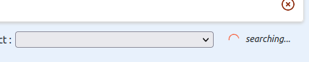

*Console Symptom* : Check in your console to see if there is a SPARQL parsing error message, like so:

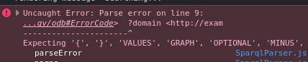

(in our case here, a missing dot in the SPARQL).

*How to fix it* : fix your SPARQL query, make sure you edit it in a tool with syntax checking.

**Case 2 : The query to the endpoint failed (the server is unreachable, or there is a CORS issue, etc.)**

*UI Symptom* : the loader keeps running, the list is not populated.



*Console Symptom :* you will see a network query failing in the network console:



(in our case here, we simulated a CORS issue).

*How to fix it* : check more in detail why the network call failed. This could be for a security reason, a CORS reason, or another reason on the server that would return an HTTP 500 error.

**Case 3 : The SPARQL query is syntactically correct and was successfully executed, but returned no results.**

*UI Symptom* : the loader stops, the list is empty



*Console Symptom :* you will see the SPARQL HTTP request to populate the list was sent and was successful, but has returned no “bindings” in its response

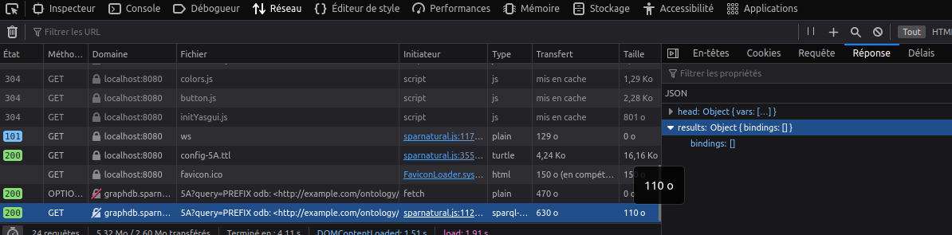

*How to fix it :* You must understand why the query does not return the expected result. To do that you need to fetch it from the HTTP request in the console:

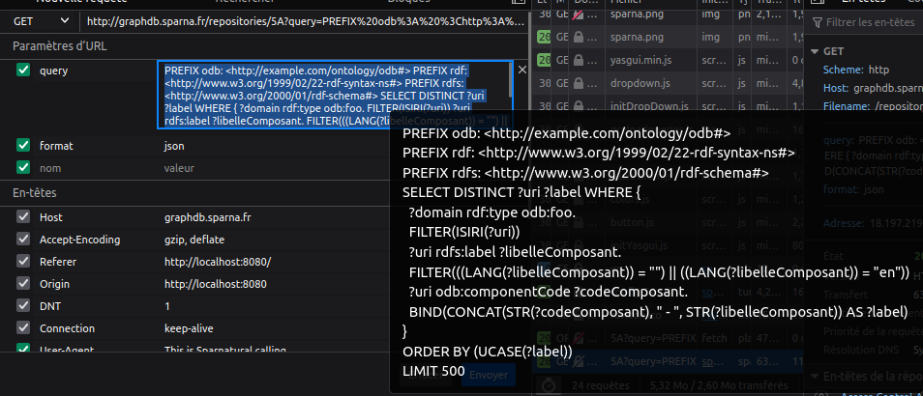

Copy the query, paste it in your triplestore SPARQL interface, and work on it to understand why it does not return the expected results.

**Warning** : remember that this is the final query being sent, after all “magic variables” have been replaced by Sparnatural with their final values. Please refer to the [datasource documentation for explanations on these variables](http://docs.sparnatural.eu/OWL-based-configuration-datasources.html" \l "your-own-sparql-query-lists--autocomplete). When you understand why the query does not work, remember to replace all fixed variables back with their magic variable name (e.g. $domain, $lang, etc.)

## Advanced configuration : setup tree widget datasource

A tree widget requires two datasources : one to get the roots of the tree, and one to get the children of a node that is unfolded. This is set with the datasources:treeRootsDatasource

and datasources:treeChildrenDatasource columns respectively, in the “Properties” tab. These two columns are useful only when the property is a core:TreeProperty, you can ignore them otherwise. The datasource documentation gives the details of the [existing default tree datasources](http://docs.sparnatural.eu/OWL-based-configuration-datasources.html" \l "preconfigured-datasources-for-a-treeproperty) and [how to create a new tree widget datasource](http://docs.sparnatural.eu/OWL-based-configuration-datasources.html" \l "your-own-sparql-query-tree). Please refer to this documentation for details.

|  |
| --- |
| ***Example***  In Sparnatural car configuration, the class odb:ErrorCode has a property odb:hasComponent, which refer to car components that re structured in a hierarchized manner. Therefore we can set this property as a core:TreeProperty with two custom tree datasources, one identified with this:tree\_root\_Component and one identified with this:tree\_children\_Component, which serve respectively to fetch the roots and the children of a node.    Selecting the core:TreeProperty widget from properties tab, these two datasources are then referred to like so :    This way the corresponding tree is displayed in the query builder :    Note how 1/ some items in the component tree are greyed out because no error codes affect them and 2/ some items in the component tree cannot be unfolded as they have no children. Those two informations (the fact that a node has children and the fact it is not referenced as a value) are computed by the SPARQL queries used as datasources, respectively in the ?hasChildren variable and the ?count variable.  The result listed is the only error code affecting the component selected in the tree up above. |

AJOUTER ANNEXE :

générer une documentation SHACL de la doc cars avec SHACL play

1. RESSOURCES POUR INTRO SHACL

   <https://github.com/veleda/shacl-masterclass>, in particular slides :

   [https://github.com/veleda/shacl-masterclass/tree/main/slides/KGC%202023](https://github.com/veleda/shacl-masterclass/tree/main/slides/KGC 2023)

   <https://www.linkedin.com/pulse/ontology-modeling-shacl-getting-started-holger-knublauch-iwlrf>

   <https://www.linkedin.com/pulse/ontology-modeling-shacl-qualified-cardinality-holger-knublauch-zp8hf/>

   <https://www.linkedin.com/pulse/ontology-modeling-shacl-sparql-based-constraints-holger-knublauch-qeisf/>

   https://www.linkedin.com/pulse/ontology-modeling-shacl-defining-forms-instance-data-holger-knublauch-ann5f/ [↑](#footnote-ref-2)
2. [↑](#footnote-ref-3)
3. [↑](#footnote-ref-4)